Abdullahi Mohamed (M00810926)

Single PAGE Web Application
[Final Report]
CST2120:

CST2120: Coursework 3: Single Page Web Application: Media Blogs
Introduction
This is the final coursework of my 2nd year at university to which my task was to create single page web application that I managed to include, a visual front-end using node and express, SQL storing and retrieving data, a content blogging style with client-side JavaScript, database design, functional and selenium testing.
Heading
Above is the heading and title name of my single page application to which I went for the colour red as it bold, appealing and the white tile name so that it noticed instantly.
Media Blogs login section

Above is a screenshot of my log in page to which it requires you to enter details that are already registered. The users that are already registered will be in the MySQL database to which it stores all the existing users. If the user inputs the incorrect details it will not login in the user instead it will return false in the login web service. Meaning that the user is selecting from my SQL database to which it then reads from the terminal.
Register section.

This is the registration page of my single page application, this is where the user inputs new details that is not on the database already. The inputted data will then be inserted into the “users” table in MySQL, therefore then can then proceed to log in right above. All information from the registered users will be stored in MySQL.

Profile section

This is part of my single page application is where when the user logs in it retrieves from the database, the name of the users. This helps keep my application flowing as it allows users to change to their suppose name this helps to keep all users content with the application as their needs are being.
Blog section


This is the blogging section of my application to which the user has the options of adding a blog and it is then retrieved into the website, also it has a foreign key that links the users table in the database to the blog table, this allows the users if to be shown in the database, had I have more time I would have retrieved it to the website but the I got it in JSON formatted data.

Database Design
Right below is an honest representation of my database design to which it exactly the table format in MySQL database dump and that the content matches the titles names of design under.
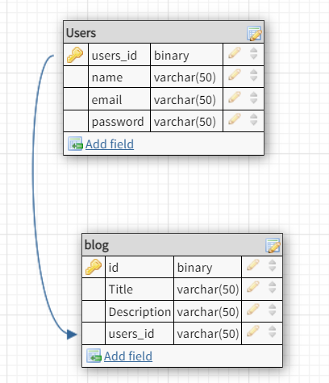

Functional HTML Test
I have managed to do my functional testing for my CSS to which it came back with zero errors.
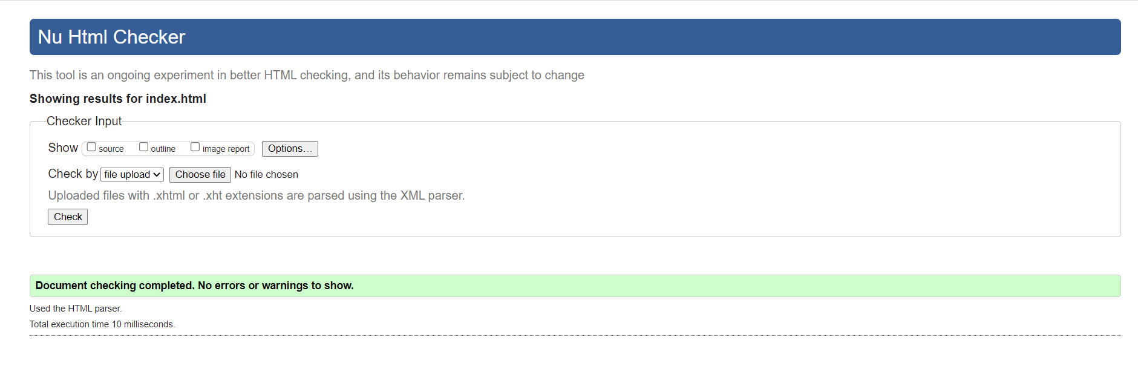

CSS Functional Testing
Below it is my functional testing for CSS to which it came with zero errors. The purpose of this was to see if there were any errors in my code.
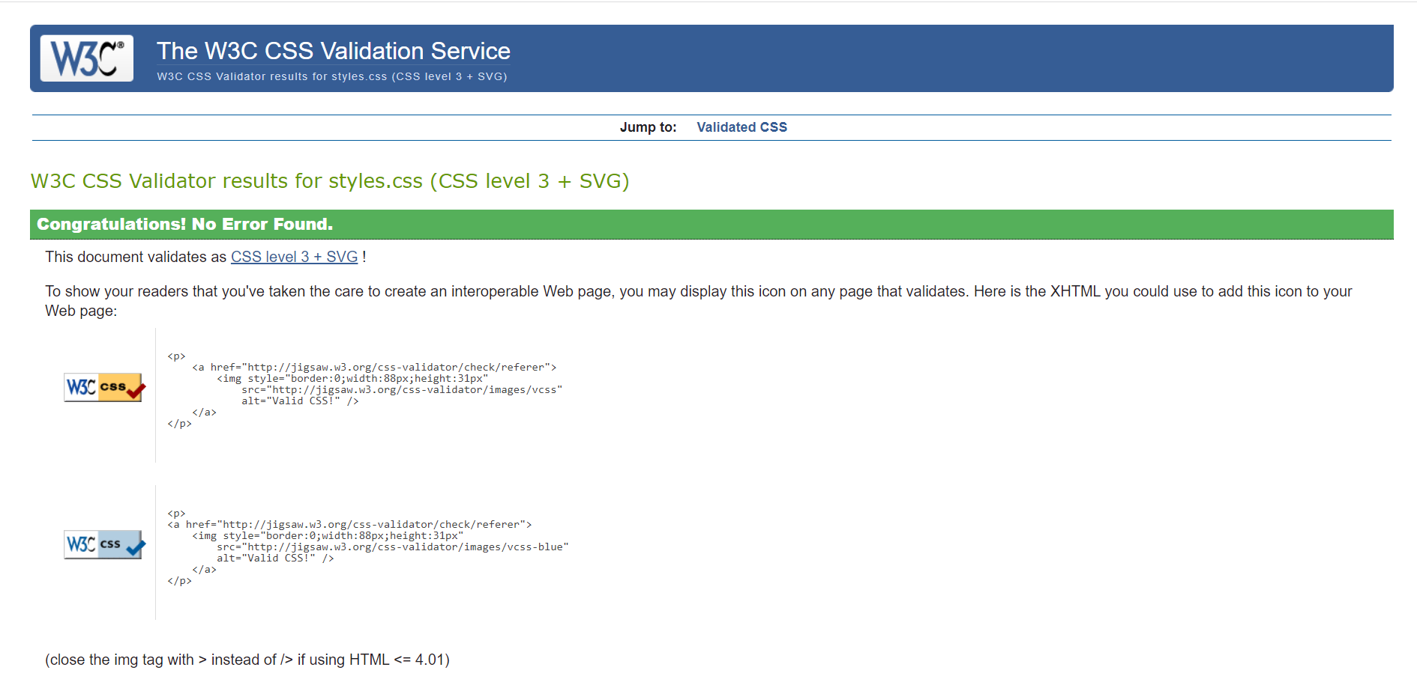
User Login Selenium Test (assertions not included)
This is the commands of my selenium activities when you login a current user from the database.
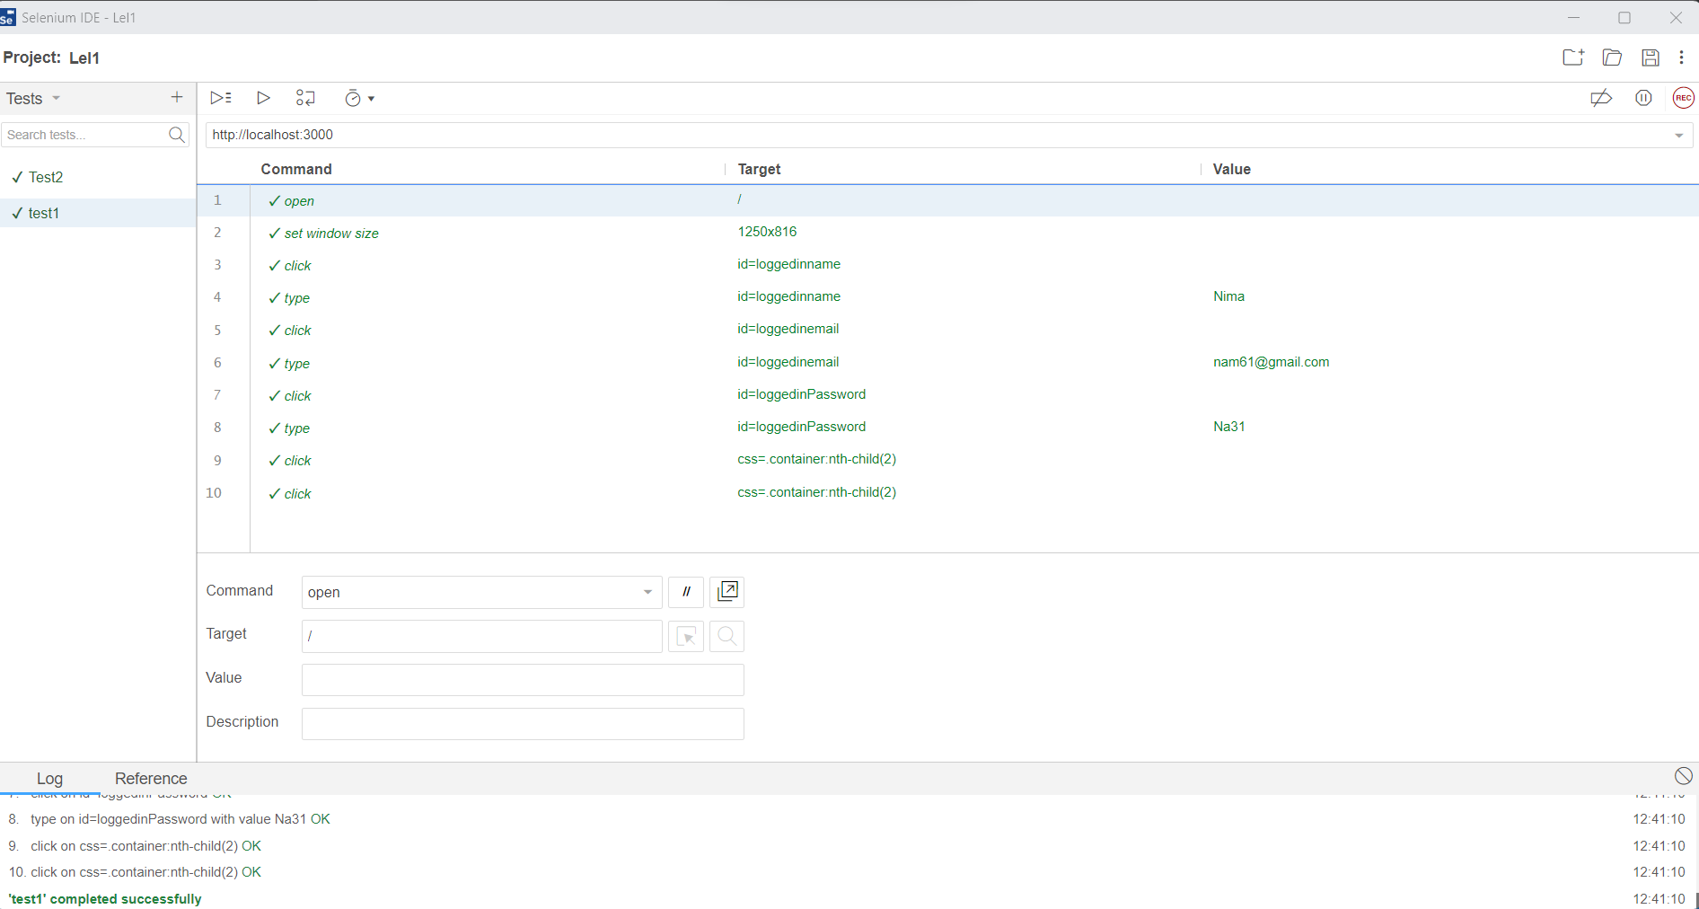

Register Selenium Testing (assertions not included)
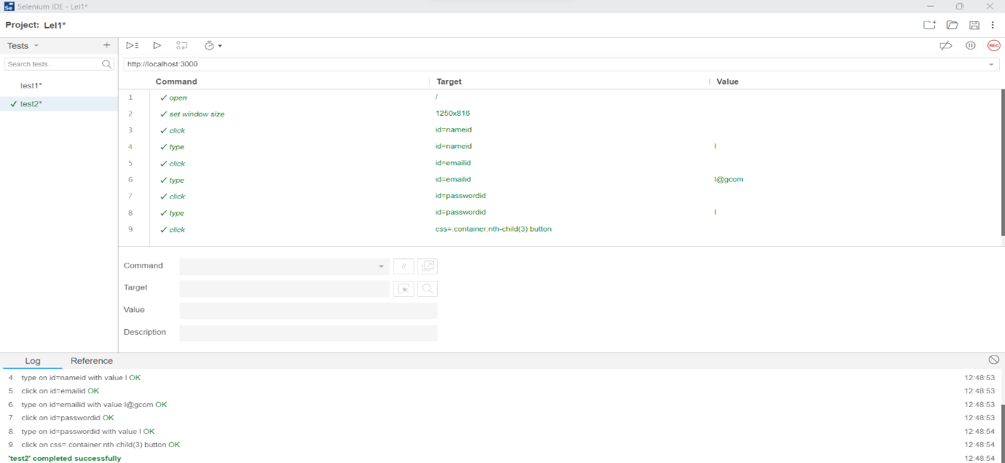
This is the selenium testing commands that I got when registering a new user.

Profile Image Selenium Test (assertions not included)
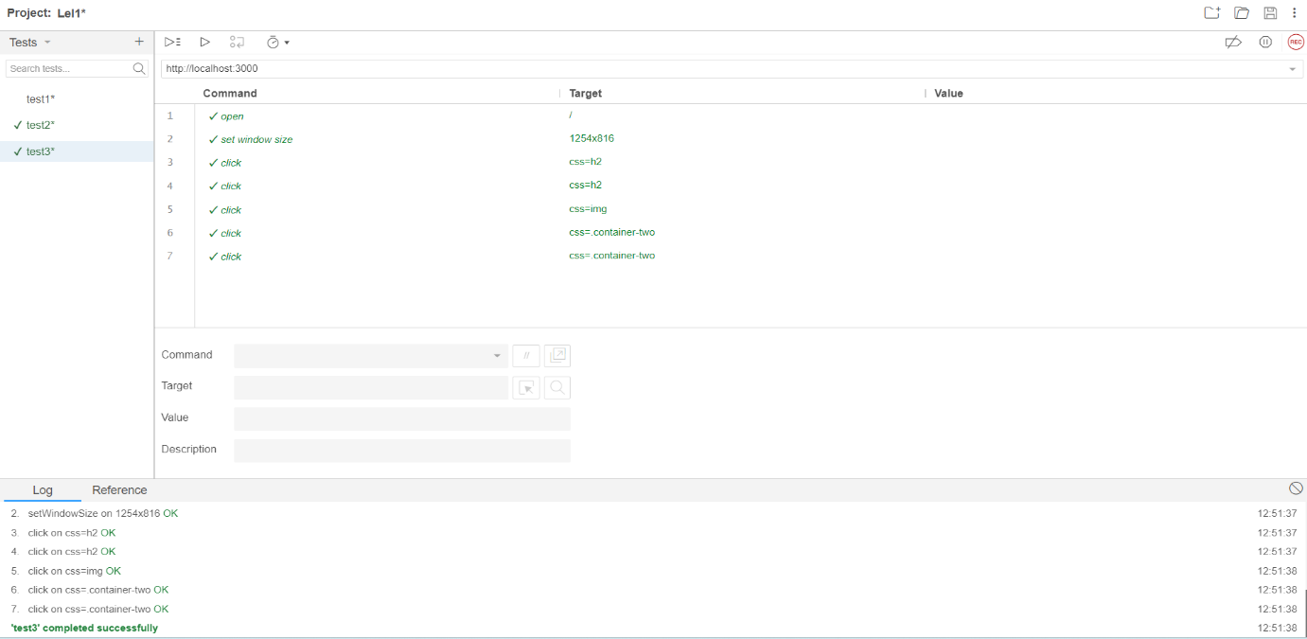
This is the commands when testing my profile picture images and text, assertions were not included.

Blog content selenium test (assertions not included)
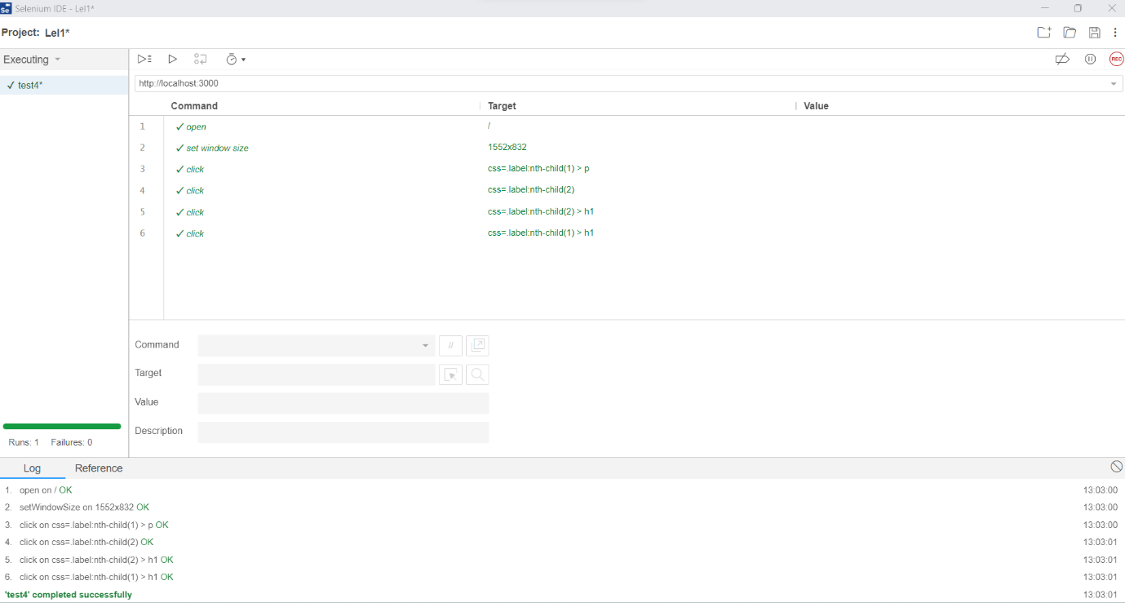
This was my 4th test to which it highlights over the current content of the blog section.

Home Title Selenium Test (assertions not included)
This was my final test to which I tested my accuracy of blog title and headings, and it came back successful.
